STATE OF MONTANA NATURAL STREAMBED AND LAND PRESERVATION ACT
OFFICIAL COMPLAINT

1. Alleged Violator: Daniel H. Rambo
Tax Address: 14 Valewood Crescent, Ottawa, ON
Phone No: __________________________
2. Landowner Name: (where alleged violation took place): Daniel H. Rambo
Address: Legal Description: S25, T30 N, R31 W, ACRES 36.68, TR 1J in SWSE *9213*
Phone No: ___________________________
3. Location of Activity:
Name of perennial stream: Libby Creek
Legal description: S25, T30 N, R31 W, C.O.S. 4562, PARCEL B1 IN SW, ACRES 15.05
Address of Activity: _________281 Dolphin Way, Libby, MT, 59923_____________________________________________________
4. Nature of Complaint:
A.Provide a specific written description of the activity:
A Hazardous wing dam of woody debris was deposited into stream bed of Libby Creek. This has been unmanaged since the Dec 2025 flood. This obstruction has created an artificial and unpermitted diversion of water, or creating lateral migration of the Libby Creek, and downstream bank erosion. This hazard has caused or contributed to approximate 1 acre land avulsion and bank erosion/failure. This has resulted in bare face and near vertical banks. The affected stream bank or property is at 281 Dolphin Way, Libby MT. The landowner tax address is out of the country. We respectfully request that this hazard be mitigated and or removed. This will limit lateral migration of Libby Creek and help maintain pre-flood creek channel. This will also help protect the remaining downstream bank, prevent erosion, and minimize risk to associated home, outbuildings at the downstream property.
B.Attach a sketch of the site. Note any landmarks.
See photos
C.Provide photos if available.
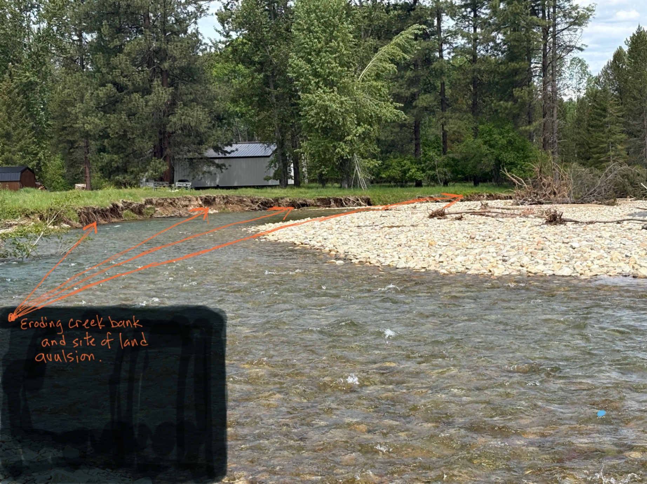
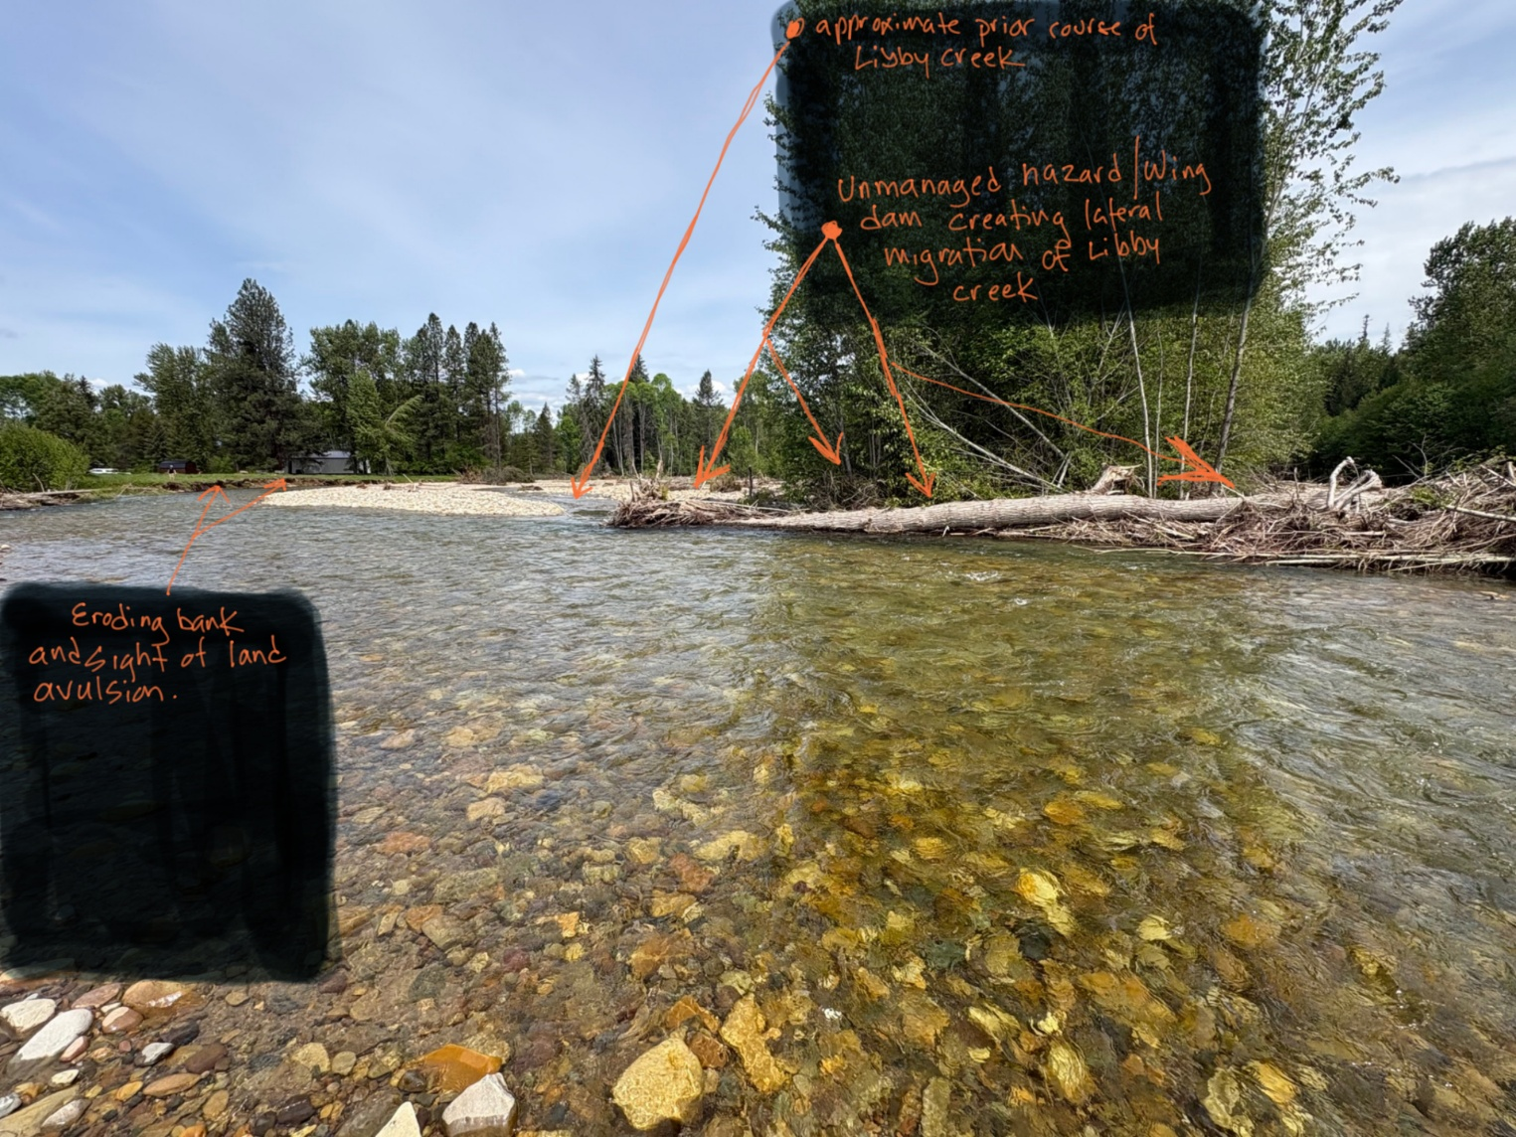
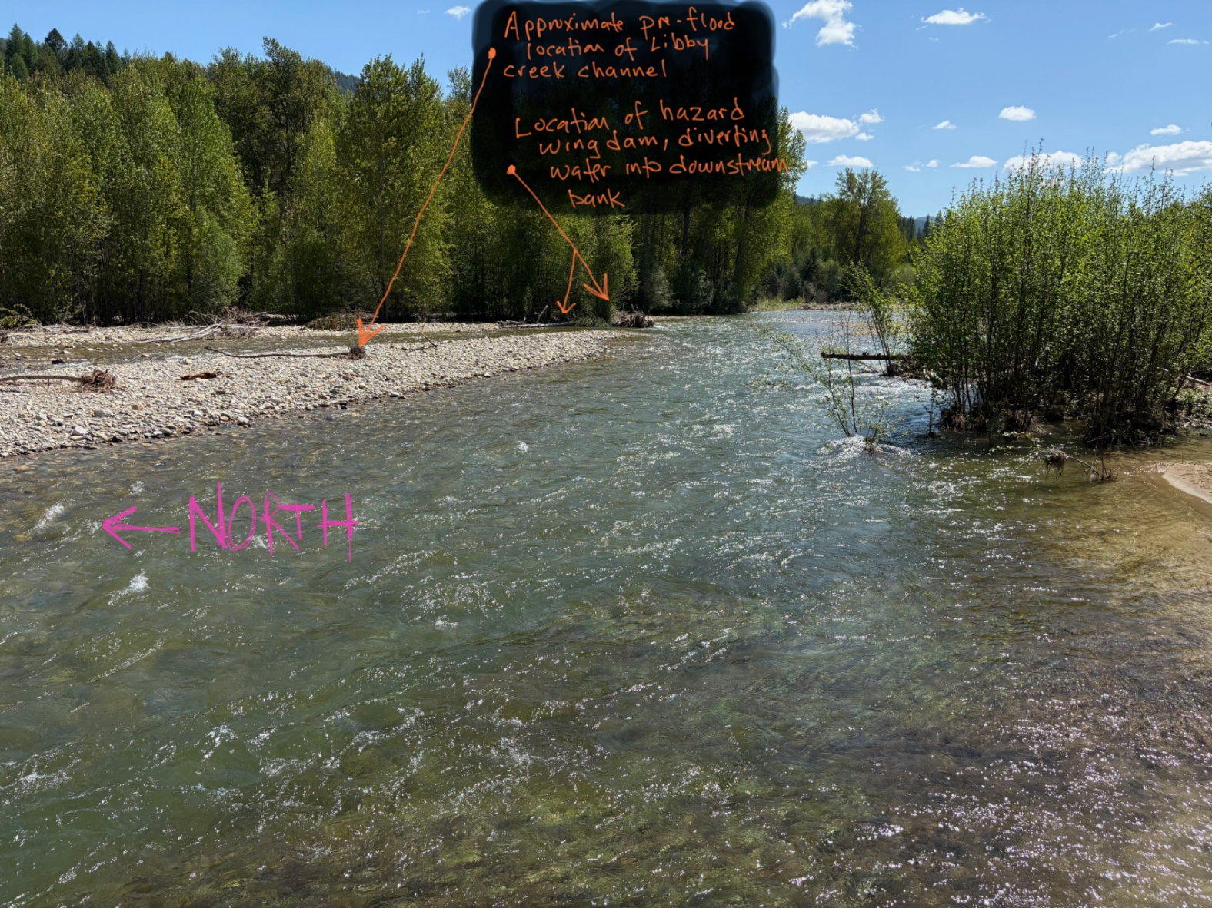
5. Verification of Alleged Violation:
A.Please state whether you have personally viewed the site of the alleged violation.
Yes, we have personally viewed the site of the violation and ongoing hazard.
B.The date of the viewing: ___________Dec 2025 to current date.__________________________________________________
C.Is the site viewable from public property (i.e. county/state road)? ____________No_________________
D.If the site is not viewable from public property, who’s permission is needed to get to a viewable site?
Jacob Christian
816-344-3164
E. If you have not viewed the site, please state the basis that forms your belief that a violation is occurring.
6. Complainant’s Signature
Printed Name: Jacob Christian
Address: 281 Dolphin Way, Libby, MT 599701
Phone No: 816-344-3164

